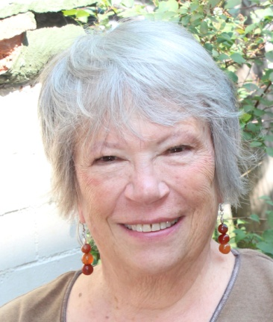
NEWS BACKGROUNDER

CONTACT: Bonnie McCune

303-377-1455

Bonnie@BonnieMcCune.com

ABOUT BONNIE McCUNE

Bonnie McCune has been writing since age ten, when she submitted a poem about rain rushing down the gutter to the Saturday Evening Post (it was rejected). Her interest in the written word facilitated her career in nonprofits where she concentrated on public and community relations and marketing. She’s worked for libraries, directed a small arts organization, and managed Denver's beautification program.

Simultaneously, she’s been a free lance writer with articles in local, regional, and specialty publications. Her civic involvement includes grass-roots organizations, political campaigns, writers' and arts' groups, and children's literacy. For years, she entered recipe contests and was a finalist once in the Pillsbury Bake Off. A special love is live theater. Had she been nine inches taller and thirty pounds lighter, she might have been an actress

Her true passion is fiction, and her stories have won several awards. Never Retreat is her third novel and her fifth book of fiction. She and her husband have two adult children, and three grandchildren. For reasons unknown (an unacknowledged optimism?), she believes one person can make a difference in this world. Visit her at www.BonnieMcCune.com, where you also can read her blog “Ordinary People, Extraordinary Lives.”

BonnieMcCune.com
Bonnie@BonnieMcCune.com
twitter.com/bonniemccune
P.O. Box 300453 ▪ Denver, CO 80203-0453
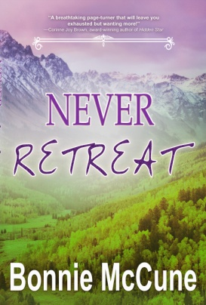
www.facebook.com/AuthorBonnieMcCune
www.linkedin.com/in/BonnieMcCune

NEVER RETREAT
A NEW WOMAN’S NOVEL, from Bonnie McCune
Imajin Books 2018, 978-1-77223-350-6 Kindle ebook
978-1-77223-351-3 Trade paperback

